

## PROJECT REPORT ON

**Development of Kenaf Fiber Natural Composite Panel**

The work undertaken at

**Vega Aviation product Pvt. Ltd**

NH4A, SY. NO 230 231/2, BELGAUM,

Khanapur Rd, Desur, Karnataka-590014

*Submitted in partial fulfillment of the requirements for the award of the degree*

## Bachelor of Engineering in

**Mechanical Engineering**

**Submitted by**

|  |  |
| --- | --- |
| **NAME** | **USN** |
| **Ms. Shakainah P Achary** | **01FE19BME077** |



## 2022-2023

School of Mechanical Engineering, KLE Technological University, Hubballi



**School of Mechanical Engineering**

## CERTIFICATE

Certified that the Project work entitled “**Design and Development of Product using Kenaf natural fiber composites**” carried out by the Team**,** Bonafide students of **K L E Technological University, Hubballi** in partial fulfillment for the award of Bachelor of Engineering /Bachelor of Technology in **Mechanical Engineering** during the year **2022-2023.** It is certified that all corrections/suggestions indicated for Internal Assessment have been incorporated in the Report deposited in the departmental library. The Project report has been approved as it satisfies the academic requirements in the said Degree.

|  |  |  |
| --- | --- | --- |
| Name:  Prof. Gurupadayya Hiremath | Name: | Name: |
| Signature: | Signature: | Signature: |
| (Internal Guide)  External Viva | (Coordinator, SME) | (Registrar) |

Name of the examiners Signature with date

1

2.



**Vega Aviation product Pvt. Ltd**

NH4A, SY. NO 230 231/2, BELGAUM,

Khanapur Rd, Desur, Karnataka-590014

## CERTIFICATE

Certified that the Internship work carried out by the Team , Bonafide students of KLE TECHNOLOGICAL UNIVERSITY in partial fulfillment for the award of Bachelor of Engineering in MECHANICAL ENGINEERING of the K L E Technological University, Hubballi during the year 2022-2023.It is certified that he has completed the internship satisfactorily.

## ACKNOWLEDGEMENT

It was my immense pleasure to accomplish my capstone project at industrial niche called as Industry Internship Project . This project helped me to enhance the skills in the domain of composites, Natural composites, Design and Manufacturing sector. It has also helped me to know the Industrial environment of project execution and terms and policies.

I had a great experience to work under the guidance **of Mr. Dev Mirajkar** (Industry Internship Coordinator) . He helped me out in all his busy schedule and made himself free to clarify doubts. He visualized me the real scenario of the plant with specifying the technical aspects from his immense experience.

My special thanks to the University, Vice chancellor **Dr. Ashok Shettar,** Dean Academic affairs **Dr. P.G.Tewar**i and HOD **Dr. B.B.Kotturshettar** for providing me an opportunity of Internship and carrying out my B.E project in the Industry.

I would like to express my special gratitude and thanks to my University guide **Prof. Gurupadayya Hiremath** for his time to clarify the doubts. His guidance helped me to plan for the next steps and established a source of confidence in execution of this project. I would also like to thank Anand L(Internship Coordinator) and all the University staff for their co-ordination and constant support in completing this project.

Support from my parents and friends helped me to travel through this amazing journey with

confidence.

Student signature

(TEAM )

## Table of Contents

* 1. Abstract 1
  2. Introduction - Significance of proposed work 2
     1. Advantages and disadvantages 3
     2. Factors affecting mechanical performance of NFCs 4
     3. Natural Fiber Composites Market Trends 6
  3. Problem Statement 7
  4. Objective of the project 7
  5. Literature Review 8
  6. Literature review on composites 8
  7. Classification on composite materials 9
  8. Literature review over natural fiber 10
  9. Fiber 11
  10. Animal Fiber 11
  11. Mineral Fiber 14
  12. Literature review on Kenaf natural fiber 14
  13. Literature review on Phenol Formaldehyde 14
  14. Properties of Phenol Formaldehyde 15
  15. Literature review on the application of natural fiber composites in Helmet manufacturing

16

* 1. Literature review on the application of natural fiber composites in

Automobile industry

3.0 Materials 17

* 1. Experimental methods for composite manufacture- Hydraulic Hot pressing 18

machine

* 1. Sheet Molding Compound or Composite (SMC) 19
  2. GMT Compression Molding 20
  3. Tube rolling 21
  4. Injection Molding 22
  5. Preparation of Kenaf fiber pre- preg and manufacture of

23

composite laminate

* 1. Calculation of Kenaf fiber and resin

24

* 1. Test Methods- Tensile test
  2. Flexural test 25

26

* 1. Impact test
  2. Water absorption test 27

28

* 1. Analysis
  2. Tensile test analysis-Total Deformation 29

29

* 1. Tensile test analysis-Equivalent Stress
  2. Flexural test analysis-Total Deformation 30
  3. Flexural test analysis-Equivalent Stress

31

* 1. Impact test analysis-Total Deformation 32
  2. Impact test analysis-Equivalent Stress 33

7.0 Applications- Mud Guard

34

* 1. Mud-guard using Natural fiber 35
  2. Helmet 36

37

* 1. Natural fiber Helmet

38

* 1. Results and discussions
  2. Tensile test results

39

* 1. Flexural test results 39
  2. Impact test results 40

41

* 1. Water absorption test results 42

9.0 Conclusions 43

10.0 Future scope on project 44

* 1. References 45

# LIST OF TABLES

|  |  |  |
| --- | --- | --- |
| **TABLE NO** | **TITLE** | **PAGE NO** |
| 1 | The production rate of fibers throughout the world per year | 13 |
| 2 | Summarizes the mechanical properties of selected natural fibers. | 13 |
| 3 | The rate of various materials used for the preparation of specimen | 17 |
| 4 | Tensile test results | 37 |
| 5 | Flexural test results | 38 |
| 6 | Impact test results | 38 |
| 7 | Weight of specimen before and after soaking in water at different intervals of time | 39 |

|  |  |  |
| --- | --- | --- |
| **FIGURE NO** | **TITLE** | **PAGE NO** |
| 1 | The representation of composite material | 8 |
| 2 | The representation of laminates | 8 |
| 3 | The representation of classification of matrices | 9 |
| 4 | The different classification of fibers | 11 |
| 5 | 1. Different animal fibers 2. Different mineral fibers | 12 |
| 6 | Shows the images of different natural fibers | 12 |
| 7 | The Hydraulic hot pressing machine | 18 |
| 8 | Sheet Molding Compound or Composite (SMC**)** | 19 |
| 9 | GMT Compression Molding | 20 |
| 10 | Tube rolling | 21 |
| 11 | Injection Molding | 22 |
| 12 | 1. Kenaf fiber mat cut according to the   specimen size   1. Semi cured Coated Kenaf- pre-preg and 2. Cured composite in compression molding machine | 23 |
| 13 | 1. Final specimen for tensile test 2. Tensile test carried out in UTM | 25 |

|  |  |  |
| --- | --- | --- |
| 14 | 1. Final specimen for flexural test 2. Flexural test carried out in UTM | 26 |
| 15 | 1. Final specimen for Impact test 2. Impact test carried out in Izod impact   testing machine | 27 |
| 16 | 1. Final specimen for water absorption 2. Each specimen immersed in water | 28 |
| 17 | Tensile test analysis Total Deformation | 29 |
| 18 | Tensile test analysis  Equivalent stress | 30 |
| 19 | Flexural test analysis Total Deformation | 31 |
| 20 | Flexural test analysis Equivalent stress | 32 |
| 21 | Impact test analysis Total Deformation | 33 |
| 22 | Impact test analysis  Equivalent stress | 34 |
| 23 | Mud-guard | 35 |
| 24 | Mud-guard using Natural fiber | 36 |
| 25 | Helmet | 37 |
| 26 | Natural Fiber helmet | 38 |
| 27 | Stress versus strain | 39 |
| 28 | 1. Stress versus strain plots for kenaf fiber pre-preg laminates 2. Stress strain plot for the averaged values | 40 |

**Abstract**

Recently, there has been a rapid growth in research and innovation in the natural fiber composite (NFC) area. Interest is warranted due to the advantages of these materials compared to others, such as synthetic fiber composites, including low environmental impact and low cost and support their potential across a wide range of applications. Much effort has gone into increasing their mechanical performance to extend the capabilities and applications of this group of materials. This review aims to provide an overview of the factors that affect the mechanical performance of NFCs and details achievements made with them.

The increase in the concern towards the environment has made the natural fiber composites an attractive option to replace the synthetic fiber reinforced composites. Natural fiber reinforced polymer matrix composites are finding applications in auto-tech, bio-medical, food packaging and other fields. The objective of this work is to prepare kenaf fiber reinforced pre- pregs using phenol formaldehyde (PF). The prepared pre- pregs are stacked one above the other and compressed in compression molding machine at a pressure of 29 Kg/cm2 and temperature of 150°C for 20 minutes. The resulting composite specimens were subjected to mechanical tests for tensile, flexural, impact behavior. Further, to know the physical behavior, water absorption test was carried out. In order to check the bio-degradability, degradation test was carried out. To reduce the weight and increase the efficiency of automobile vehicles, manufacturer develops the automobile accessories using natural fibers like kenaf instead of using synthetic fibers. As a part of this study, the mud-guard as automobile accessories taken for product development and for this mold was designed and fabricated to get the final product. Finally the product was manufactured using the kenaf fiber pre- preg laminate technique

.

Keywords: Kenaf fiber, Pre- preg laminates, Phenol formaldehyde

# CHAPTER 1

**INTRODUCTION**

## Significance of proposed work

In recent days the application of natural fibers by replacing synthetic fibers leads to the development of new and eco-friendly materials in various sectors. In earlier stage more emphasize given for the polymeric composites and they are using in different sectors such as automobile industry, aerospace and house hold application. These composite has a properties like good stability, corrosion resistance and light weight but these polymeric composites are not environmental friendly and bio-degradable in nature. The natural fibers are a source of highly renewable resources and offer advantages of properties like biodegradability, low density, non- abrasive nature, and low cost. Natural fibres like Jute, Sisal, Hemp, Kenaf, Coconut-coir, Flax, Banana and Bamboo etc. are considered as environmentally friendly materials. These natural fibres when blended with phenol formaldehyde, the resulting natural fibre composites are inviting it for various applications. The most commonly used matrices for bio- fibers are thermoplastic, they are polypropylene, polyethylene, and polyvinyl chloride (PVC) .While phenol formaldehyde, epoxy and polyester resins are the most commonly used thermosetting matrices, showing Kenaf fibres having a density around about 1.0-1.2gcm-3 and tensile strength about 700 MPa and the CO2 absorption rate that exists in plant life is best in kenaf, If the processing temperature is above 200°C, then the cellulose in the kenaf fibres begins to degrade and it does not retain its mechanical properties. Since the kenaf fibre reinforced composites have low melting temperature and the processing temperature normally lower than 200°C. The huge amount of shear force is involved during compounding process and molding process such as injection molding process and resulted in the fibre length sapping. fibre length sapping resulted in the compromised mechanical properties of the final natural fibre composite product,. Phenol formaldehyde is a phenolic resin, it is invented by dr.leo Baekeland in 1907.The phenolic resins are most favored and flexible high volume resin systems. They are having the properties like fine machinable, light in weight, and it can handle the temperature up to 300-350°C and good corrosion resistance.

### 1.1.2

Interest in NFCs is growing for many reasons including their potential to replace synthetic fiber reinforced plastics at lower cost with improved sustainability; their advantages and disadvantages are summarized below

|  |  |
| --- | --- |
| Advantages: | Disadvantages |
| * Low density and high specific strength   and stiffness | * Lower durability than for synthetic fibre composites, but can be improved considerably with treatment |
| * Fibres are a renewable resource, for which production requires little energy, involves CO2 absorption, whilst returning oxygen to the environment | * High moisture absorption, which results in swelling |
| * Fibres can be produced at lower cost than synthetic fibre | * Lower strength, in particular impact strength compared to synthetic fibre composites |
| * Low hazard manufacturing processes | * Greater variability of properties |
| * Low emission of toxic fumes when subjected to heat and during incineration at end of life | * Lower processing temperatures limiting matrix options |
| * Less abrasive damage to processing equipment compared with that for synthetic fibre composites |  |

The main factors affecting mechanical performance of NFCs are:•fibre selection – including type, harvest time, extraction method, aspect ratio, treatment and fibre content,

* + - matrix selection,
    - interfacial strength
    - fibre dispersion,
    - fibre orientation
    - composite manufacturing process and
    - porosity.

## Factors affecting mechanical performance of NFCs

### Fibre selection

Fibre type is commonly categorized based on its origin: plant, animal or mineral. All plant fibres contain cellulose as their major structural component, whereas animal fibres mainly consist of protein. Although mineral-based natural fibres exist within the asbestos group of minerals and were once used extensively in composites, these are now avoided due to associated health issues (carcinogenic through inhalation/ingestion) and are banned in many countries. Generally, much higher strengths and stiffness are obtainable with the higher performance plant fibres than the readily available animal fibres. An exception to this is silk, which can have very high strength, but is relatively expensive, has lower stiffness and is less readily available. This makes plant-based fibres the most suitable for use in composites with structural requirements and therefore the focus of this review. Furthermore, plant fibre can suitably be grown in many countries and can be harvested after short periods.

Generally, higher performance is achieved with varieties having higher cellulose content and with cellulose micro fibrils aligned more in the fibre direction which tends to occur in bast fibres (e.g. flax, hemp, kenaf, jute and ramie) that have higher structural requirements in providing support for the stalk of the plant. The properties of natural fibres vary considerably depending on chemical composition and structure, which relate to fibre type as well as growing conditions, harvesting time, extraction method, treatment and storage procedures. Although increasing fibre length generally increases fibre load bearing efficiency, if fibre length is too long the fibres may get tangled during mixing resulting in poor fibre dispersion which can reduce the overall reinforcement efficiency

### Matrix selection

The matrix is an important part of a fibre-reinforced composite. It provides a barrier against adverse environments, protects the surface of the fibres from mechanical abrasion and it transfers load to fibres. The most common matrices currently used in NFCs are polymeric as they are light weight and can be processed at low temperature. Both thermoplastic and thermoset polymers have been used for matrices with natural fibres

However, it should be noted that the thermoplastics named constitute the most common thermoplastics consumed by the plastics industry and far outweighs the use of any other thermoplastic matrices generally used. Indeed, PP and PE are the two most commonly adopted thermoplastic matrices for NFCs. The main thermosets used are unsaturated polyester (UP), epoxy resin, phenol formaldehyde and VE resins. Thermoplastics are capable of being repeatedly softened by the application of heat and hardened by cooling and have the potential to be the most easily recycled, which has seen them most favored in recent commercial uptake, whereas better realization of the fibre properties are generally achieved using thermosets.

### Interface strength

Interfacial bonding between fibre and matrix plays a vital role in determining the mechanical properties of composites. Since stress is transferred between matrix and fibres across the interface, good interfacial bonding is required to achieve optimum reinforcement, although, it is possible to have an interface that is too strong, enabling crack propagation which can reduce toughness and strength. However, for plant based fibre composites there is usually limited interaction between the hydrophilic fibres and matrices which are commonly hydrophobic leading to poor interfacial bonding limiting mechanical performance as well as low moisture resistance affecting long term properties. For bonding to occur, fibre and matrix must be brought into intimate contact; wettability can be regarded as an essential precursor to bonding. Insufficient fibre wetting results in interfacial defects which can act as stress concentrators .Fibre wettability has been shown to affect the toughness, tensile and flexural strength of composites . Physical treatment and chemical treatment can improve the wettability of the fibre and thus improve the interfacial strength.

### Fibre dispersion

Fibre dispersion has been identified as a major factor influencing the properties of short fibre composites and a particular challenge for NFCs, which commonly have hydrophilic fibres and hydrophobic matrices. Use of longer fibres can further increase their tendency to agglomerate. Good fibre dispersion promotes good interfacial bonding, reducing voids by ensuring that fibres are fully surrounded by the matrix. Dispersion can be influenced by processing parameters such as temperature and pressure; additives such as stearic acid have been used in PP and PE to modify dispersion as well as those used to increase interfacial bonding such as MAPP which encourage fibre matrix interaction. Similarly, fibre modification through grafting can also be employed, but is more expensive. Although the use of more intensive mixing processes such as using a twin-screw extruder rather than a single screw extruder leads to better fibre dispersion, this is generally at the cost of fibre damage and fibre lengths are found to reduce dramatically during such processing depending on temperature and screw configuration.

### Fibre orientation

The best mechanical properties can generally be obtained for composites when the fibre is aligned parallel to the direction of the applied load .However, it is more difficult to get alignment with natural fibres than for continuous synthetic fibres. Some alignment is achieved during injection molding, dependent on matrix viscosity and mould design. However, to get to higher degrees of fibre alignment, long natural fibre can be carded and placed manually in sheets prior to matrix impregnation. Alternatively, traditional textile processing of fibres can be employed including spinning to enable a continuous yarn to be produced. One study on aligned Alfa fibre reinforced UP showed strengths compared to those obtained in the fibre direction (0°) of 69%, 29%, 22% and 12% at angles of 10°, 30°, 45° and 90° respectively and corresponding Young’s modulus of 93%, 66%, 52% and 41% of that in the fibre direction.

### Manufacturing

The most common methods used for NFCs are extrusion, injection molding (IM) and compression molding. Resin transfer molding(RTM) is also used with thermoset matrices and pultrusion has been successfully employed for combined flax /PP yarn composites and thermoset matrix composites. Factors determining properties include temperature, pressure and speed of processing. Compression molding (CM) is generally used for thermoplastic matrices with loose chopped fibre or mats of short or long fibre either randomly oriented or aligned, but can also be used with thermoset matrices. The fibres are normally stacked alternately with thermoplastic matrix sheets before pressure and heat are applied. The viscosity of the matrix during pressing and heating needs to be carefully controlled, in particular for thick samples to make sure the matrix is impregnated fully into the space between fibres.

### Porosity

An often overlooked component of NFCs, porosity has long been known to have shown to have a large influence on mechanical properties of composites in general and much effort has gone into reducing it in synthetic fibre composites. It arises due to inclusion of air during processing, limited wettability of fibres, lumens and other hollow features within fibres/fibre bundles (which may become closed during processing at high pressure) and due to the low ability of fibres to compact. Porosity in NFCs has been shown to increase with fibre content, more rapidly once the geometrical compaction limit has been exceeded, dependent on fibre type and orientation of fibre.

## Natural Fiber Composites Market Trends

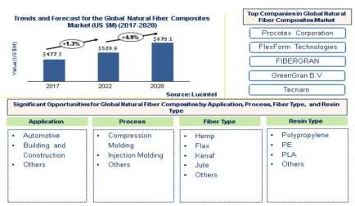The future of the global Natural Fiber Composites market looks promising with opportunities in the beauty and personal care market. The global natural fiber composites market is expected to reach an estimated $679.1 million by 2028 with a CAGR of 4.9% 2022 to 2028. The major driver for the growth of this market is the rise in demand for lightweight and environmentally sustainable composite materials in various applications, such as automotive, building & construction, and others.

### Problem Statement

The aim of our work is to development of composite panel using Kenaf natural fibers with PF resin. Initially Kenaf fiber reinforced pre- pregs using phenol formaldehyde (PF) was prepared. The prepared pre- pregs are used to get composite laminate of required size and then characterized for mechanical and physical response of resulting composite. Finally the panel undergoes various test check its durability

### Objective of the project

Following are the set of objectives made to develop the eco-friendly, light weight material

using natural fibers.

* + - * An extensive literature was made for the selection of natural fiber and matrix material.
      * To investigate the physical properties of Kenaf fiber reinforced composite panel.
      * Kenaf natural fiber pre-pregs were developed using phenol formaldehyde resin.
      * The Kenaf composite laminate was manufactured using kenaf pre-pregs for various mechanical tests like tensile, flexural, impact and physical tests like water absorption and degradation test, to know the mechanical and physical response.
      * Design and analysis of the developed composite panel to check its durability.

# CHAPTER 2 LITERATURE REVIEW

Fibers or particles combines with matrix of another material to get the composite materials. The diagrammatical representation is shown in the figure 1. Beghezan defines the composite as “The composites are compound materials which differ from alloys by the fact that the individual components retain their characteristics but are so incorporated into the composite as to take advantage only of their attributes and not of their short comings”, in order to obtain improved materials.

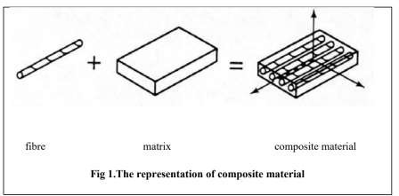

Laminates are a composite material which is produced by combining the different layers of same materials or different materials. It is shown in the figure 2.

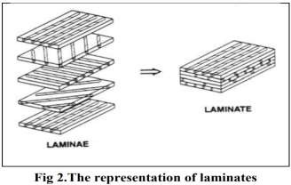

## 2.1. Classification of composite materials

The composite material is classified in to four types they are:

* + - * + Polymer matrix composites
        + Metal matrix composites
        + Ceramic matrix composite
        + Carbon and graphic matrix composites

**Polymer matrix composites**: in polymer matrix composites matrix material is polymer. Since the strength and stiffness of these polymers are low compared to other metals, polymers are reinforced with the other materials. The manufacturing method is very easy since it doesn’t require any high temperature and pressure conditions

**Metal matrix composites**: these composites have some advantageous properties like high specific strength, high specific modulus and lower coefficient of thermal expansion. Due to these properties it is having wide range of application like heat exchangers, housings, cables etc.

**Ceramic matrix composites**: Ceramic matrix composites having higher value of toughness, hence in order to improve the strength ceramic matrix composites are used.

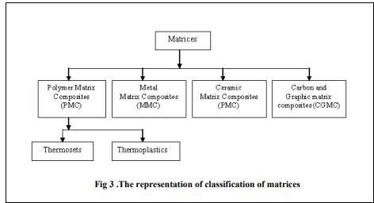

9

## Literature review over the natural fiber

### Fibre

The word fiber is defined as the thread like structure which has a high aspect ratio. The fibers are classified in to three types they are as follows. The diagrammatical representation of classification is shown in the figure 4.

Natural fibre or vegetable fiber

Animal fiber

Mineral fiber

**Natural fiber:** Natural fiber is the type of fiber in which fibers is available from the plant source. The fibers are available in nature hence the name natural fibers. The plants sources are classified in to two types. They are primary and secondary plants. Primary plants are the plants in which the fibers are extracted from the grown plants Secondary plants are the plants in which the fibers are produced from the by-product of the plants.

These natural fibers are classified as follows

Seed fiber: The fibers extracted from the seeds. For example: cotton

Leaf fiber: The fibers which are collected from the leaves. For example: sisal

Bast fiber: It is also called skin fiber. It is extracted from the skin surrounding the stem

of their respective plant

Fruit fiber: It is obtained from the fruit. For example: coconut coir.

Stalk fiber: The fibers obtained from stalks of the plant. For example: rice and tree wood. The most used natural fibers are sisal, Kenaf, hemp, cotton, flax, jute and banana fibers

## Animal fibers

The fiber extracted from animals.it is shown in the figure 5(a). For example silk, wool and alpaca. Animal fiber are classified as follows

* Animal hair: fiber extracted from the animal hair. For example: sheep’s wool, goat hair
* Silk fiber: fibers obtained from the insects during the cocoons preparation. For example:

silk from silk worms

* Avian fibers: fibers from birds. For example: feather fibers

## 2.2.3 Mineral fibers

A mineral fiber obtained from the minerals.it is shown in the figure 5(b). They are classified as follows

* Asbestos :it is the naturally occurring mineral fiber
* Ceramic fibers
* Metal fibers

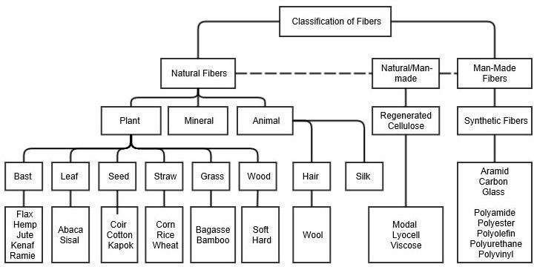

### Fig.4 Classification of Fibers

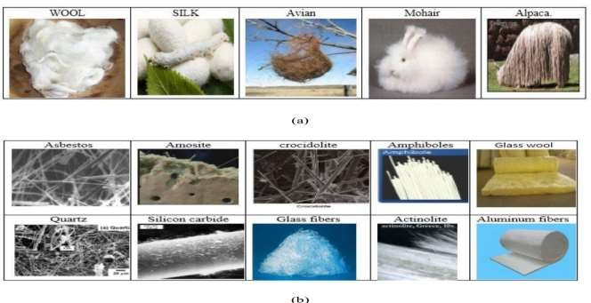**Fig.5 Images showing (a) Different animal fibers**

### (b) Different mineral fibers

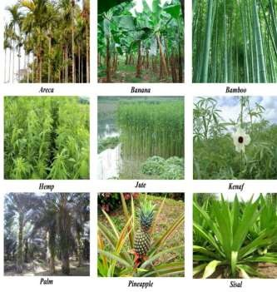

**Fig 6 shows the images of different natural fibers**

## Table 1 shows the production rate of fibers throughout the world per year

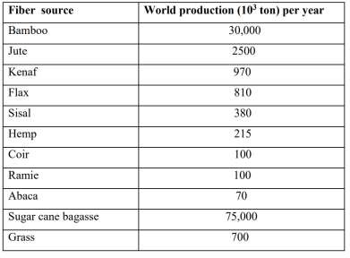

**Table.2 Summarizes the mechanical properties of selected natural fibers.**

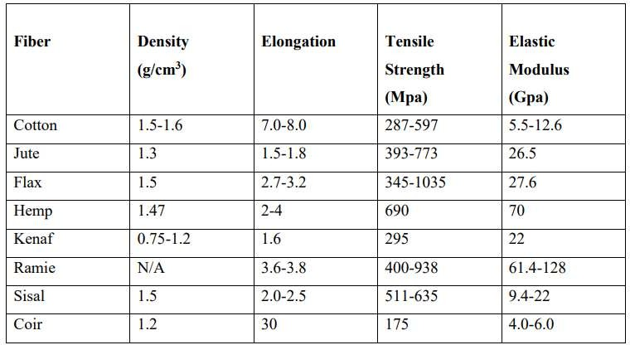

## Literature review on Kenaf natural fibers

The Kenaf natural fibre is belongs to the bast fiber. It is the family of hibiscus. It is one of the biodegradable and environmentally friendly crops. The density is around 0.75-1.2 g/cm3 .the Kenaf fibres is having fine and clear fibres. It is having the cellulose (45-57%), hemicelluloses (21.5%), lignin (8-13%) and pectin (3-5%).It is having tensile strength about 295Mpa. After 160 days of sowing kenaf stalks harvested and were kept straight in the field for twenty days, until stalks were thoroughly dried and leaves gets started to fall. Then to accelerate the retting process, the dried kenaf stalks sprayed with 2 percent urea. Then for retting process bundles of stalks were immersed in water tank. In order to remove the vegetative matter slacked fibres are beaten. The fibres were extracted and washed completely with clean water and kept in sunlight for drying purpose, Gumgol et al. [10]. The Kenaf fibres are available in the form of paper pulp and mat. kenaf fibre mat is produced by wet laid process.

## Literature review on phenol formaldehyde resin

Phenol formaldehyde resins are of two types .they are

* + - * + Resole type
        + Novolacs type

Resole type: Due to the presence of reactive side groups, this type of resins does not require any cross linking agent, it is self curing. it is prepared by base catalyzed. it is formed by the reaction between phenol and formaldehyde in water with catalytic amount of base. it is carried out at above room temperature.

Novolacs type: this type of resins require cross linking agent to get fully polymerize. it is formed at below pH level 7.

## Properties of phenol formaldehyde resin

* + - * + Most favored and flexible high volume resin systems
        + Fine machinable
        + Light in weight
        + It can handle temperature up to 300-350°c
        + Good corrosion resistance
        + Humidity absorption is very less
        + Dielectric strength is high
        + Creep resistance is high at elevated temperatures.

## Literature review on the application of natural fiber composites in

**helmet industries**

Recently, bio composite materials are synthesized using natural cellulose fibers as reinforcements together with matrix, which have attracted the attention of researchers due to their low density with high specific mechanical strengths, availability, renewability, degradable and being environmental-friendly. The present work attempts to make an improvement in the current existing helmet manufacturing methodology and materials used to have better mechanical properties as well as to enhance the compatibility between fibers and the matrix. The bio- composite are prepared with the unsaturated polyester matrix and fibers such as E-glass fiber, sisal fiber using hand lay-up method with appropriate proportions to result in helmet shell structure. The fabricated helmet are planned to evaluate its mechanical properties such as tensile strength, impact strength and compression strength

The major environmental problem faced today is the non degradable plastic wastes The tremendous production and use of plastics in every segment of our life has increased the plastic waste in huge scales increased the plastics wastes in huge scales. The waste disposal problems, have directed grate part of the scientific research to eco composites materials that can be easily degraded or bio assimilated. Natural fibers have advantages such as low cost and very light weight however they suffers from lower mechanical properties compared to glass fibers .in the present study an attempt has been made to reinforcement epoxy resins matrix with multiple nature fibers and to characterize its mechanical performance to evaluate their suitably for helmet application.

### SAFETY

Max total deformation in natural composite is 0.01mm which is less than total deformation

0.207mm

### ADVANTAGE

Comparing to conventional reinforcing fibers like glass, carbon and Kevlar, natural fibers have the following advantages:

Environmentally friendly

Fully biodegradable

Non toxic

Easy to handle

Non abrasive during processing and use

Low density/lightweight

Source of income for rural/agricultural community

Renewable, abundant and continuous supply of raw materials

Low cost

## Literature review on the application of natural fiber composites in automobile industries

In recent years automobile industries are making attempts to decrease the use of petroleum based products due to increase in the environmental related concern. This leads to development of environmentally friendly products. Since the plastic fibre which is used in automobile sector, it has high carbon composition and more over it is not degradable hence it affects the environment. The hybrid material replaces this plastic material which is already in use. The hybrid composite material has less carbon composition. The Roselle/Banana/Sisal hybrid fibers reinforced with polymer composites used in manufacturing the automobile parts. The automobile accessories like a rear view mirror, indicator cover and visor in two wheeler is manufactured by using the sisal and Roselle hybrid composite by hand layup technique. But the problem of hybrid composite is the failure of the component. Due to which fibre, the failure occurs is difficult to analyze.

The secondary structural components in automotive is increasingly developed by Kenaf fibre composites. Toyota Motor Corporation developed the interior components by using Kenaf fiber polypropylene composite material. General Motors developed the package trays and door panel inserts for Saturn L300s and European-market Opel vectras by using Kenaf and flax hybrid composite. Kenaf/Ramie hybrid composite has been used as the material for automotive headliner. In European country they recently developed light weight electric motor vehicle by using flax and hemp hybrid composites.

# CHAPTER-3

## Materials

By considering the above literature review on fibers and its application in the various

industries, we finally chosen the Kenaf fiber by considering the following points.

Compared to other natural fibres like flax and hemp, the Kenaf fibres are very fine and clear which is very important for the purpose of achieving a high-quality surface finish.

Since the Kenaf plant belongs to bast fibre, it scores less density around 0.75-1.2 g/cm3

Kenaf fiber-reinforced composite is exhibits good mechanical properties like excellent damping characteristic and biodegradability. Kenaf fibre is having 52% of cellulose content and high strength up to 295 MPa.

We use the Kenaf fibers in the form of mat. Reason behind for choosing the Kenaf fibers in the form of mat are:

In the random form of Kenaf fibre, Uniform distribution of fibres in the resin is not takes place. But it is possible in case of Kenaf fibre mat.

Orientation is the second major problem, but in the Kenaf fibre mat we get the

bidirectional orientation of fibers.

The bi-directional Kenaf fibre mat was purchased from the Go Green products Chennai. Phenol formaldehyde resin (PF) resoles type was purchased from Acolyte Synthetics, Mangalore, and Karnataka.

## Table 3. The rate of various materials used for the preparation of specimen

|  |  |  |
| --- | --- | --- |
| **SL.NO** | **MATERIALS** | **RATE(kg/lit) or**  **(1 sq.mt)** |
| 1 | Phenol formaldehyde | 130 |
| 2 | Kenaf fiber | 810 |

 

# CHAPTER-4

**EXPERIMENTAL METHOD FOR COMPOSITE MANUFACTURE**

## Hydraulic Hot pressing machine

Hydraulic hot pressing machine is developed for the programmed of development and performance analysis of bio-based fibre composites in GMIT

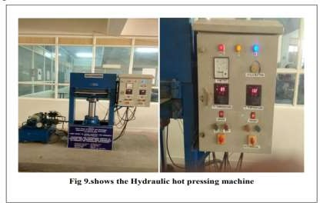

Details of the hydraulic hot pressing machine is given below Specifications:

* + - * Capacity: 20 tons
      * Type: up stroking
      * Ram dia:200mm
      * Stroke:300mm
      * Daylight:300mm
      * Platen size(hot plate):600X300
      * Platen heating media: electrical heated
      * Heating capacity: up to 200 deg

### SPEED:

Approach:21mm/sec Pressing:2mm/sec Return :by gravity

Working pressure:130kg/cm2 Oil reservoir capacity:150lts Electric motor:3HP

Overall dimension:1600X2000X800mm

## Sheet Molding Compound or Composite (SMC)

Sheet molding compound (SMC) or sheet molding composite is a ready to mold glass –fiber reinforced polyester material primarily used in compression molding. This is manufactured by dispersing long strands (usually >1”) of chopped fiber, commonly glass fibers or carbon fibers on a bath of thermoset resin (typically polyester resin, vinyl ester resin or epoxy resin)

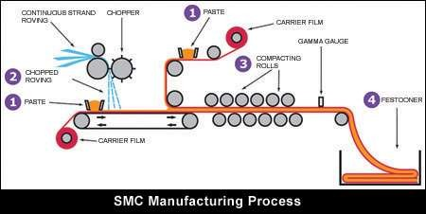

**Fig.8 Image of SMC Manufacturing Process**

## Physical properties

|  |  |
| --- | --- |
| * Density | : 1.1–2.0 g/cm3 (69–125 lb/cu ft) |
| * Impact Strength | : 4–11 J/cm (7–21 ft⋅lbf/in) |
| * Flexural Strength | : 120–230 MPa (17–33 ksi) |
| * Flexural Modulus | : 10–15 GPa (1,500–2,200 ksi) |
| * Tensile Strength | : 55–125 MPa (8–18 ksi) |
| * Tensile Modulus | : 7–14 GPa (1,000–2,000 ksi) |
| * Compressive Strength | : 130–220 MPa (19–32 ksi) |
| * Heat Deflection Temperature at   1.82 MPa (264 psi) | : 200–260 °C (392–500 °F) |
| * Heat Deflection Temperature at   0.455 MPa (66 psi) | : 115–180 °C (239–356 °F) |
| * Curing Temperature | : 80–150 °C (176–302 °F) |

* 1. **GMT Compression Molding**

Compression molding is a lightweight technology that allows to preserve fiber length and retain better mechanical properties compared to injection molding. In compression molding development, a suitable material such as glass fiber mat thermoplastics (GMT) is often used. Where 60% by weight Resin and 40% by weight glass mat is used.

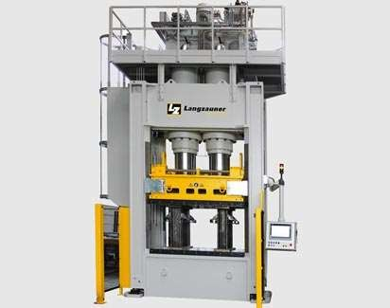

### Fig.9 GMT compression machine

**Specifications**

* + - The pressure is from 500 to 40,00 tons, which can work under very high pressure
    - The maximum pressing plate size is 3,000 X 2,500 mm
    - Opening 3,000 mm
    - Stroke 2,000 mm
    - Quick closing speed 600mm/s
    - Working speed 20 mm/s
    - Quick opening speed 600mm/s
    - The cycle time ranges from 45 seconds for structural parts to 120 seconds for the most technical parts.

## Tube rolling

Tube rolling is a long-standing composites manufacturing process for producing finite- length tubes and rods. The pattern pieces are laid out on a flat surface and a mandrel is rolled over each one under applied pressure, which compacts and debulks the material.

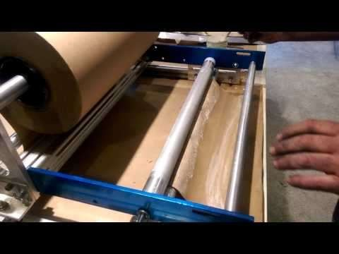

### Fig. 10 Tube rolling machine

**Specifications**

* + - Small-diameter cylindrical or tapered tubes in lengths up to 6.1m/20 ft.
    - Tubing diameters up to 152 mm/6 inches can be rolled efficiently

## Injection Molding

IM process is a popular manufacturing method for mass production. High process ability is the key concern in favor of IM though the reinforcement fiber degrades during the process. A wide number of natural fiber can be used as a reinforcement for the composite in injection molding.

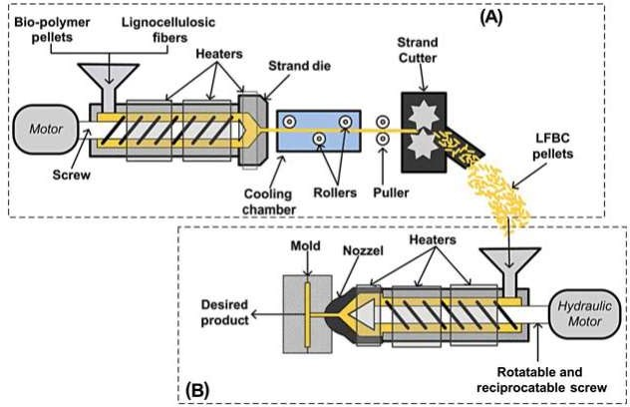

### Fig.11 Injection Molding Machine

**Specifications**

* + - Holding pressure of 0.7 and 1.5 Mpa
    - Preheated mold (40°C)
    - Barrel temperature range of 140—190°C
    - Nominal clamping force of 850 kN
    - Screw L/D ratio of 21
    - Screw diameter of 40 mm
    - Screw speed of 120 rpm
    - Injection pressure of 50 Mpa
    - Injection speed of 0.2 m/s

### Preparation of Kenaf fiber pre- preg and manufacture of composite laminate

To prepare the kenaf fiber pre-preg , initially Kenaf fiber mat was cut with size 333mmx224mmx3mm which is shown in Figure 12(a).Measured quantity of resin is taken in the glass beaker and, then each kenaf fiber mat is coated with phenol formaldehyde resin (PFR) on both the sides by using the paint brush. Then it was allowed to partial curing under room temperature for 24 hours as shown in Figure 12(b).After this curing we got the kenaf fiber pre- preg. Finally the composite laminate was taken out and which is shown in the Figure 12(c)

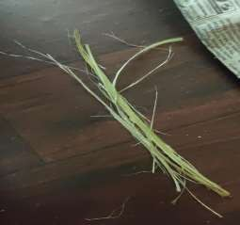

### Fig. 12 (a) Kenaf fiber

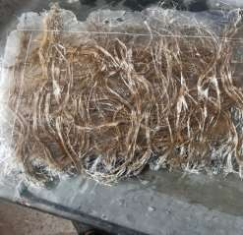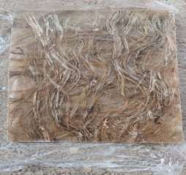

**(b) Semi cured Coated Kenaf- pre-preg and (c) Cured composite**

## Calculation for (50/50) weight ratio of Kenaf fiber and resin

Total vol. Of composite =333mmx224mmx3mm

=223776mm3

50% volume of Kenaf fiber =0.5x223776

=111888mm3

50% volume of resin =0.5x223776

=111888mm3

Weight of Kenaf fiber=density of Kenaf fiber x volume of fiber

= (1X10-3 ) x (111888)

=111.888gms

Weight of resin=density of resinxvolume of resin

= (1.21X10-3) X (13500)

=135.384gms

# CHAPTER -5

**TEST METHODS**

## 5.0 Tensile test

The tensile specimens are cut according as per ASTM Standard .The final specimen for tensile test is as shown in the figure 13.The dimension of each specimen was 150mmx15mmx3mm The tensile test was carried out using Universal Testing Machine (UTM) of 10KN capacity is shown in the figure 13. Typical test speed was maintained 3 mm/min for all the specimens

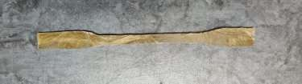

### Fig 13(a) Final specimen for Tensile test

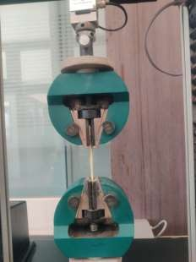

**Fig 13(b) Tensile test carried out in UTM**

## Flexural test

The flexural test specimens are cut according to the ASTM standard. The flexural test was carried out in the Universal Testing Machine (UTM) using three point loading attachments are shown in the figure 15(b). Flexural test specimen with dimension of 125mm×12mm×3mm is shown in the figure 15(a).

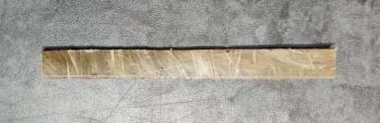

### Fig 14(a) Final specimen for Flexural test

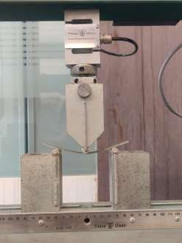

**Fig 14(b)flexural test carried out in UTM**

## Impact test

The test specimens are cut according to ASTM D4812.The final specimen for impact test is as shown in the figure 16(a) and it is carried out in the izod impact testing machine as shown in the figure 16(b)

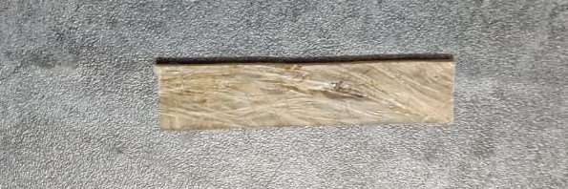

### Fig 15(a) Final specimen for Impact test

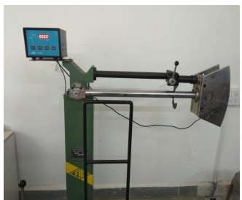

**Fig 15(b) izod impact testing machine**

## Water absorption test

The test specimens are cut according to standard. The appearance of specimen surface after water absorption test is shown in the Figure 16The dimension of each specimen was 20mm×20mm×3mm.Water absorption test was done by soaking the specimen in water and measuring the weight periodically. Before starting the absorption experiments, the specimens were dried in an oven at 50°C for 2 hours. Then each specimen was immersed in a separate container containing water. The weights of each specimen were measured after definite time intervals. The absorption study was done by weighing the soaked samples at every 24, 48, 72, and 96 hrs to check weight loss and finally appearance was seen in Figure 16(b).

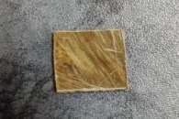

### Fig 16 (a) Final specimen for Water absorption

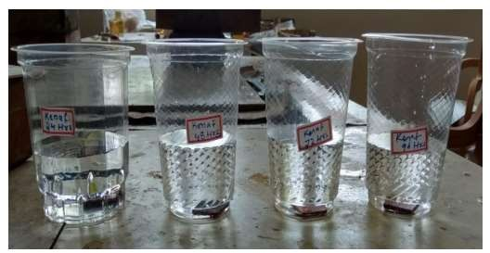

**Fig 16(b) each specimen immersed in water in separate container**

# CHAPTER-6 ANALYSIS

## Tensile test analysis Total Deformation

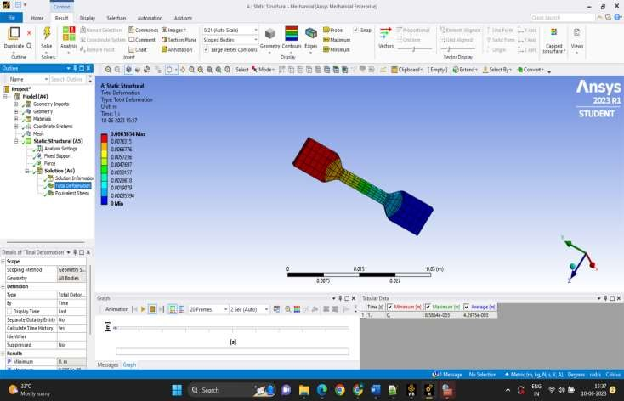

**Fig 17**

## Tensile test analysis Equivalent Stress

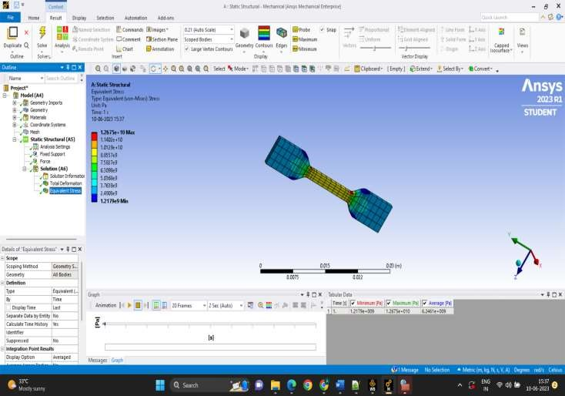

**Fig 18**

## Flexural test analysis

**Total Deformation**

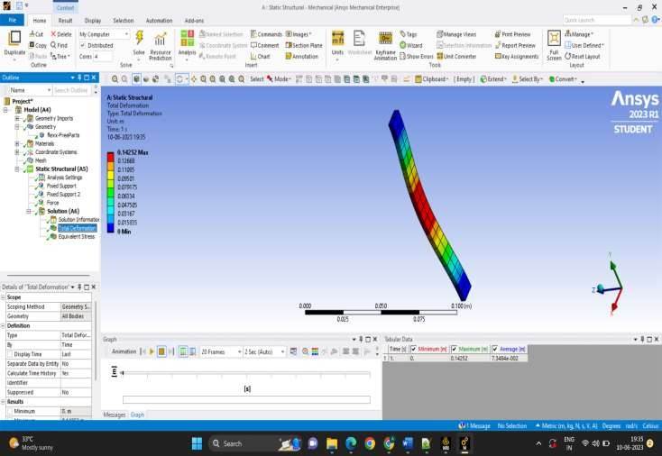

**Fig 19**

## Flexural test analysis

**Equivalent Stress**

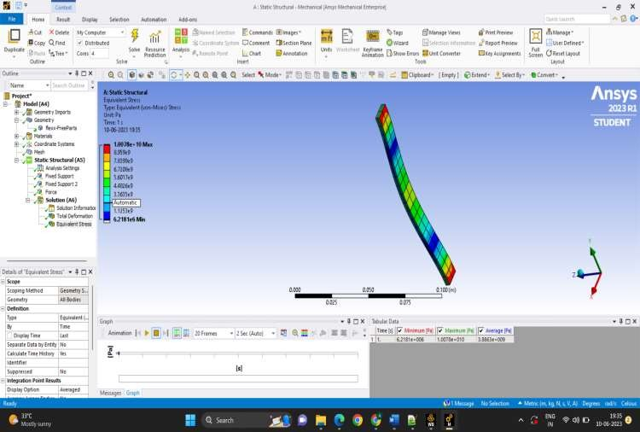

**Fig 20**

## Impact test analysis Total Deformation

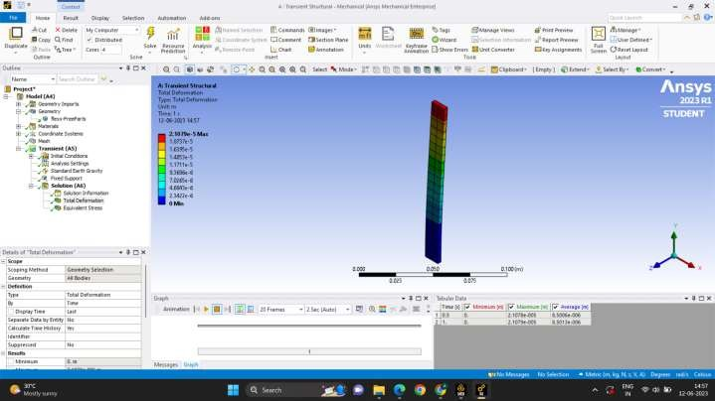

33

**Fig 21**

## Flexural test analysis Equivalent Stress

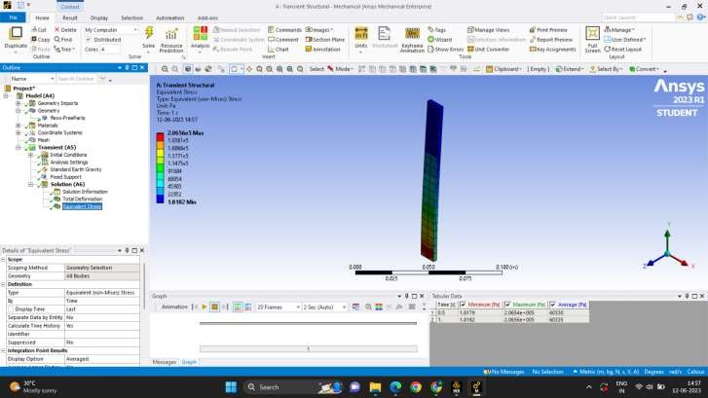

**Fig 22**

# CHAPTER-7

**APPLICATIONS**

## Mud-guard

The mud-guard is the part of the automobile, which protects it from the mud

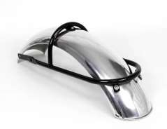

### Fig. 21 Stainless steel mudguard

**DISADVANTAGES:**

If the mudguards are made out of steel, they’re highly likely to rust even if the steel is stainless.

Quality metal mudguards tend to be more expensive for the following reasons:

* + - Higher grade materials
    - Lower demand
    - Exquisite Craftsmanship
    - Heavier (potentially)

## Mud-guard using Natural fiber

Composite materials are widely used nowadays in various fields due to their unique property in weight. Reduction, High strength and rigidity and low cost.

In order to reduce the weight of the vehicle, the spare parts of an automobile were manufactured by natural fiber composites.

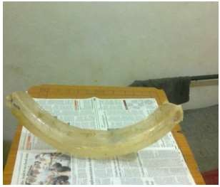

### Fig. 22 Natural fiber mudguard

* + - The application of green composites in automobile body parts seems to be feasible as far as green composites have comparable mechanical performance with synthetic ones.
    - The weight of composite mudguard is comparatively low than the weight of the

conventional two wheeler mudguard.

* + - Studies indicate that natural fiber composites can contribute to a cost reduction of 20% and weight reduction of 30% of an automotive part, light weight of components leads to lower fuel consumption, good recycling possibilities, reduction in waste disposal and greenhouse emissions which are some of main drivers for use of natural fibers

## 7.3 Helmet

In helmet manufacturing gathering of the raw materials used to create the finished product. This typically includes materials like polycarbonate plastic, for the exterior shell.

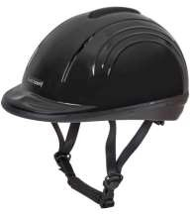

### Fig. 23 Polycarbonate helmet

**DISADVANTAGES**

* The main disadvantage of polycarbonate is that it isn't scratch resistant.
* Polycarbonate can expand
* The high price is one of the major disadvantages of polycarbonate panels
* When burned it produces thick, toxic, black smoke which can be health hazard, which is also environmentally unfriendly
* The manufacturing process is not very environmentally friendly, requiring very high processing temperatures.

 

## 7.4. Natural fiber Helmet

A composite is produced by combining two or more different materials with a matrix and its properties shows enhanced behaviour than the base materials used. Flexural test, hardness test, impact test and drop tests were conducted to analyse the mechanical properties of composite specimen and helmet. The results of the tests makes the composite a better material for use as an industrial helmet.

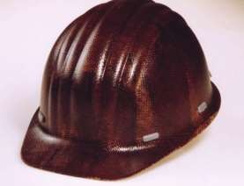

## Fig. 24 Natural Fiber helmet

* + Production cost is reduced.
  + Good mechanical properties, light weight, low cost, high specific strength, less rough surface, environmentally friendly, and good biodegradation characteristics.
  + The results have shown that natural fiber helmet withstand more stress than the other.

# CHAPTER-8

**RESULTS AND DISCUSSIONS**

## Tensile test results

The tensile test was conducted and results are tabulated in Table 4.To evaluate the tensile behavior, stress versus strain graph was plotted. Stress versus strain behavior of the kenaf fiber pre- preg laminates specimen is shown in the Figure 19.The tensile strength and tensile modulus of the laminate specimen is 22.8 MPa and 325 MPa respectively.

## Table 4.Tensile test results

|  |  |  |  |  |
| --- | --- | --- | --- | --- |
| **Load at Breaking(N)** | **Tensile strength (MPa)** | **Elongation at break (%)** | **Max. stress (MPa)** | **Tensile modulus (MPa)** |
| 1710 | 22.8 | 6.36 | 22.8 | 325 |

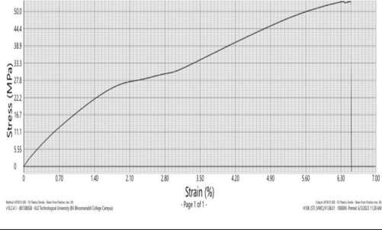

**Fig 25 Stress versus Strain curve**

## Flexural test results

The flexural test was conducted and results are tabulated in Table 5. Finally the flexural strength and flexural modulus for the kenaf fiber pre-preg laminates specimen is 87 MPa and 7200 MPa respectively.

## Table 5.Flexural test results

|  |  |
| --- | --- |
| **Flexural strength(MPa)** | **Flexural modulus (MPa)** |
| 87 | 7200 |

* 1. **Impact test results**

The impact test was conducted and results are tabulated in Table 6. Finally the energy absorbed and impact strength for the kenaf fiber pre-preg laminates specimens is averaged. The impact strength is 57(J/m) and energy absorbed is 0.171 (J).

## Table 6.Impact test results

|  |  |  |
| --- | --- | --- |
| **Specimen** | **Energy absorbed(J)** | **Impact Strength(J/m)** |
| 1 | 0.157 | 52 |
| 2 | 0.185 | 62 |
| 3 | 0.175 | 58 |

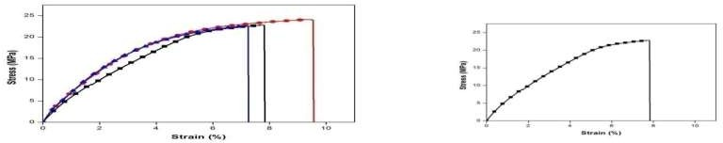

### Fig 26. (a) Stress versus strain plots for kenaf fiber pre-preg laminates

**(b) Stress strain plot for the averaged values**

## Water absorption test results

Water absorption test was conducted and results are tabulated. The weight of each soaked specimens were weighed and listed in Table 7. The water absorption behavior of all specimens was determined by measuring the percentage weight gain after soaking in water is calculated by using equation 1. From the result, it was clear that the percentage weight gain rate for the kenaf fiber pre-preg laminate specimens are almost remains same and nearly equal to 23.28%. The physical change like appearance of the specimens after soaking in water was shown in the Figure 20(b). White patches were found on the specimens after soaking in water. Percentage weight gain = [ W1−W0 ∕W0 ] × 100

**Table 7. Weight of specimen before and after soaking in water at different intervals of time**

|  |  |  |  |  |
| --- | --- | --- | --- | --- |
| **SI. No** | **Time in**  **(Hrs)** | **Weight of specimen before soaking in water(W0) in grams** | **Weight of specimen after soaking in water(W1) in grams** | **Weight**  **gain in %** |
| 1 | 24 | 1.018 | 1.250 | 22.78 |
| 2 | 78 | 0.994 | 1.215 | 22.23 |
| 3 | 72 | 0.940 | 1.178 | 25.31 |
| 4 | 96 | 1.030 | 1.312 | 27.37 |

# CHAPTER-9 CONCLUSIONS

The kenaf fiber reinforced pre- pregs are successfully developed using phenol formaldehyde. This method is more economical and quick processes of preparing. The prepared pre- pregs are used to make the composite laminates using compression molding technique. The performance of kenaf pre-preg laminate in tensile, flexural was carried out according to ASTM standard test procedures. In addition, water absorption test was conducted to evaluate the physical behavior of kenaf fiber pre-preg laminate. It is concluded that kenaf fiber pre- preg laminate specimen resulted in the tensile strength of 22.8 MPa, tensile modulus of 325 MPa and flexural strength of 87 MPa. Impact strength of 57 J/m and energy absorbed was 0.171 J The percentage weight gain rate for kenaf fiber pre-preg laminate specimen after different intervals of time remained nearly same. The weight of the specimen kept for degradation test is gradually decreasing as the number of days increasing. The change in the physical appearance and mechanical strength of the specimens subjected to degradation test was noticed. The small porous holes are formed on the specimens and the fiber surfaces are started to vanish.

Among various natural materials, natural fibers offer several advantages over synthetic materials in reinforcing composites, due to their biorenewable characteristic and eco-friendly behavior, and can be thus effectively utilized for various applications.

# FUTURE SCOPE ON PROJECT

To increase the biodegradability, the work will be extended by selecting bio resin. Since the Kenaf has extremely low density fibers hence same work will be extended to make other parts of automotives. Different natural fibers are used to fabricate the different products using the same pre-preg laminate technique.

# REFERENCES

1. H.M. Akil *et al.*[Kenaf fiber reinforced composites: a review](https://www.sciencedirect.com/science/article/pii/S0261306911002639)
2. [A. Alavudeen *et al.*Mechanical properties of banana/kenaf fiber-reinforced hybrid polyester composites: effect of woven fabric and random orientation](https://www.sciencedirect.com/science/article/pii/S0261306914008553)

*3. J. Eng. Appl. Sci.* **69**, 52 (2022) <https://doi.org/10.1186/s44147-022-00109-0>

[4. https://www.sciencedirect.com/science/article/abs/pii/B9780128245286000114](https://www.sciencedirect.com/science/article/abs/pii/B9780128245286000114)

[5. https://iopscience.iop.org/article/10.1088/1742-6596/908/1/012002](https://iopscience.iop.org/article/10.1088/1742-6596/908/1/012002)

6. polymers-13-02016%20(1).pdf

7. 15589250211040184.pdf

1. [https://www.sciencedirect.com/science/article/pii/S2588840420300330#bib1](https://www.sciencedirect.com/science/article/pii/S2588840420300330)
2. [Natural fiber-mediated epoxy composites – A review](https://www.sciencedirect.com/science/article/pii/S1359836816309660)
3. AJEAT-Vol.7-No.2-July-December-2018pp.-110-112.pdf 11. 7-3-121-609.pdf
4. <https://www.sciencedirect.com/science/article/abs/pii/S0959652617323946>
5. <https://www.ncbi.nlm.nih.gov/pmc/articles/PMC8228744/>
6. <https://textilelearner.net/kenaf-fiber-properties/>
7. <https://www.ncbi.nlm.nih.gov/pmc/articles/PMC7362004/>



1. ijaerv12n24_70.pdf
2. 2011-03-kenaf-an-ecological-source-for-paper.pdf 18. 199242522.pdf

19. 7408135.pdf

1. [www.astm.org](http://www.astm.org/)
2. <https://www.sciencedirect.com/science/article/pii/S1359835X15003115>